PAPER TITLE HERE
Firstname LASTNAME, Firstname LASTNAME & Firstname LASTNAME
Abstract: The abstract should not exceed 250 words. The abstract should present a concise statement of the scope, principal findings, and conclusions of the paper. The abstract should be preceded and followed by a 24 point paragraph spacing.
Style guidance
SECED Styles
This template is formatted to resemble a final paper. The template contains a number of styles named “SECED Body text”, “SECED Heading 1”, “SECED Caption”, etc. The use of SECED styles ensures that the final paper complies with the guidelines contained herein. The base font for all styles is Arial.
Paper header
The title of the paper should be centred using bold upper case 14 point all capital font with 24 point spacing above and 12 point spacing below. Authors’ full names should also be centred in 12 point font. The affiliation and email address of the first author should be given separately as a footnote on the first page. The affiliations of other authors may also be given as footnotes. Please note that due to the General Data Protection Regulations, the email addresses of other authors should not be given. The footnotes should be in 9 point font.
Headings
Two heading styles are predefined within this template (“SECED Heading 1” and “SECED Heading 2”). Further sublevels should not be used within the paper.
Body text of the paper
Paragraphs should be written in the “SECED Body text” style. The style is defined by single line spacing with 10 point font (justified) and 6 point spacing between each paragraph.
Carriage returns (blank lines) should not be added between the section headings and the body text, or between individual paragraphs. A single space should be used between sentences.
- This is an example of a bullet list.
- Second line in bullet list.
- Third line in bullet list.
- This is an example of a numbered list.
- Second line in numbered list.
- Third line in numbered list.
Copyright
The paper must comply with UK copyright law. It is the responsibility of the authors to obtain permissions to reproduce material obtained from other publications (if permission is required under copyright law). In submitting the paper to the conference, the author(s) give permission that SECED may publish the paper online and on electronic media such as USB memory sticks.
Page count and file size
The paper should not exceed 10 pages. The file size should not exceed 20MB when in pdf format.
Figures
Figures should be numbered in sequence. Figures should be centred using the “SECED Figure” style, and the figure should be positioned ‘in line with text’ using Layout Options. A “SECED blank line” may be inserted before the figure to increase the spacing between body text and the figure. Figure captions should be written in the “SECED Caption” style and be centred beneath each figure. Acknowledgements should be made if the figure is reproduced (with permission) from any other publication in brackets at the end of the caption. Axes should be clearly defined; the usage of symbols as axis labels should be avoided unless the symbols are defined in the main text. Units should be indicated on the axis labels. The legend and axes descriptions should be read easily with at least 8 point font (preferably Arial).

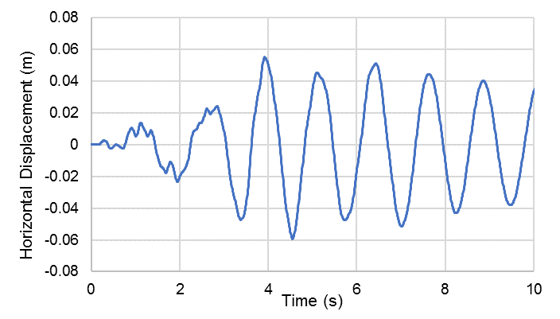
Figure 1. Figure caption here.
Tables
Table should be numbered in sequences. A “SECED blank line” may be inserted before the table to increase the spacing between body text and the table. The following table shows an example. Tables should not span multiple pages.

Table heading | Table heading | Table heading
Tables should be numbered in sequence  Each table should be mentioned in the text before the table is placed | Table captions should be based on the “SECED Caption” style. | Table text should be Arial font, at least 9 points, but preferably 10 points.
Tables should be centred, and the table size should not exceed page margins. | There should be 12pt space after the table. A “SECED blank line” may be inserted before the table to increase the spacing between body text and table. | Acknowledgements should be made if the table is quoted from any other publication in brackets at the end of the caption.
Table 1. Table caption here.
Equations and math
Equations should be formatted by means of MathType Equation Editor or the older Microsoft Equation Editor 3.0. Equations should be centred and numbered consecutively. On a new line, select the “SECED Equation” style and press tab once; type the equation, and press tab again; then type the equation number. Equation numbers should be placed at the right end of the equation line between parentheses. For example:
(1)
The equation should be written in 10 point Arial using italics for Latin symbols and normal (upright) font for Greek symbols. All symbols should be defined within the text.
Paper submission
Once completed, the full paper should be saved in PDF format and uploaded to the abstract management system (https://www.outsourcedregistration.com/seced/index.php), using your previous log-ins.
References
References should follow the Harvard style. A reference within the text is given as, for example, Clough and Penzien (1993). Standards may be referenced by their number only (e.g. BS EN 1998-1). A full list of references is required at the end of paper. Examples are shown below for a standard, a book, a PhD thesis, a paper and a website.
BS EN 1998-1:2004+A1:2013, Eurocode 8: Design of structures for earthquake resistance – Part 1: General rules, seismic actions and rules for buildings, AMD 31st May 2013
Clough RW and Penzien J (1993), Dynamics of Structures, 2nd Ed., New York: McGraw-Hill Book Company
Vu D (2002), Strength Properties of Metakaolin Blended Concrete, Ph.D. Thesis, Delft Technical University of Technology, The Netherlands
Zhang MH and Gjorv OE (1991), Effect of silica fume on pore structure of cement paste, Cement and Concrete Research, 21(1): 1006-1014
SECED (2019). SECED 2019 Conference Official Website. Available at: http://www.seced.org.uk/index.php/seced-2019 (Accessed 27/01/2019)

Title, institution, city of institution, country, email address
Title, institution, city of institution, country
Title, institution, city of institution, country

